How To Install The Serial-port Drive

Below is the install steps:

1. Right click “Computer”- “Manage”, and then find the “Device Manager”

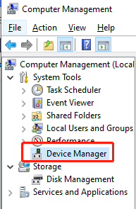

1. Connect the computer and screen via USB, then the “Port(COM&LPL)”will appear.

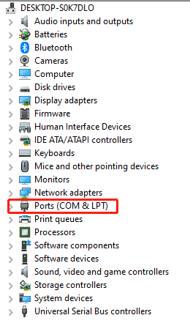

1. Right click “Port(COM&LPL)”, and click “Scans for hardware changes”
2. Select the “Browse……drivers”

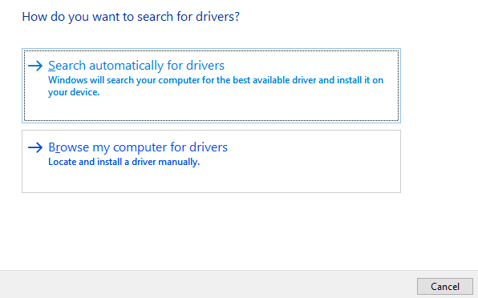

1. Click “Browse” to find the drivers in the computer, or the drivers will directly appear in it. Then click “Next”.

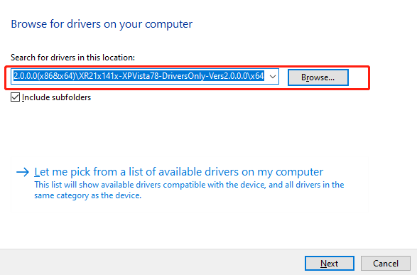

1. It will install the driver automatically.

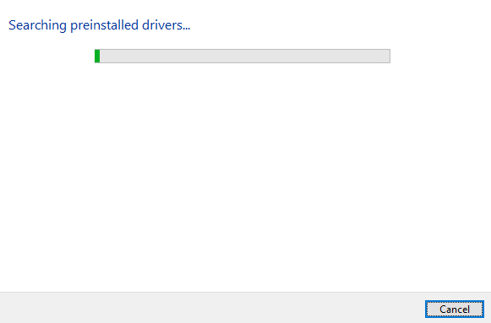

1. After the installation is complete, the port number corresponding to the driver can be viewed in the device manager.

Here is the download link: https://www.dwin-global.com/tool-page/